**Information regarding formatting:**

**Bold** = Answered question

Normal = Unanswered Question

Dark Red = Response

Red = Missing stuff

**Written by:**

Ricardo Rodriguez

Jamiro Haelg

Miki Feldmüller

**Disclaimer:**

This document was written in a group via Google Docs in an effort to reconstruct the exam “Molecular and Structural Biology I: Protein Structure and Function / Molecular and Structural Biology II: From Gene to Protein” from FS 2018. This document is not entirely complete nor do we guarantee that the answers are entirely correct or sufficiently detailed. However it is a good way to assess the difficulty and the topics of the question in the exam. Have fun with learning!

**PRÜFUNG STRUK 1&2 - FS 2018**

#### Glockshuber

**1. Exercise about a protein which has 2 domains. The protein is only described by diagrams and spectra** (Not entirely sure anymore how many diagrams/spectra and how they looked like):

- Equilibrium unfolding transition diagram

- Far-UV CD (Circular dichroism) spectra

- Fluorescence spectra at different concentrations

**Reminder what each diagram/spectra is typically used for:**

Equilibrium unfolding transition diagram: Determination of the free energy of folding

Absorption spectra: Tyrosine, Tryptophan, Disulfide bonds -> Protein concentration

Fluorescence spectra: Folded/unfolded state

Far-UV CD spectra: Folded/unfolded state, Secondary structure composition, intact tertiary structure

a) Which domain is more stable?

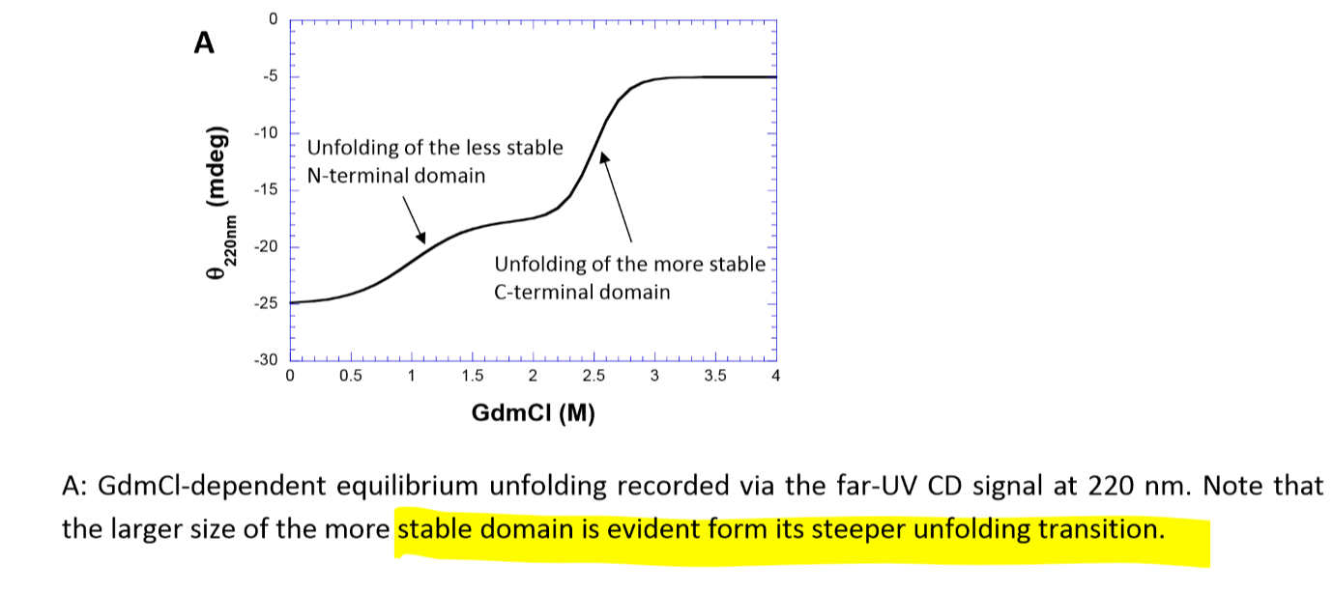

**b) What is the main secondary structure content of the N and C domain?**

Siehe Far-UV CD spectra:

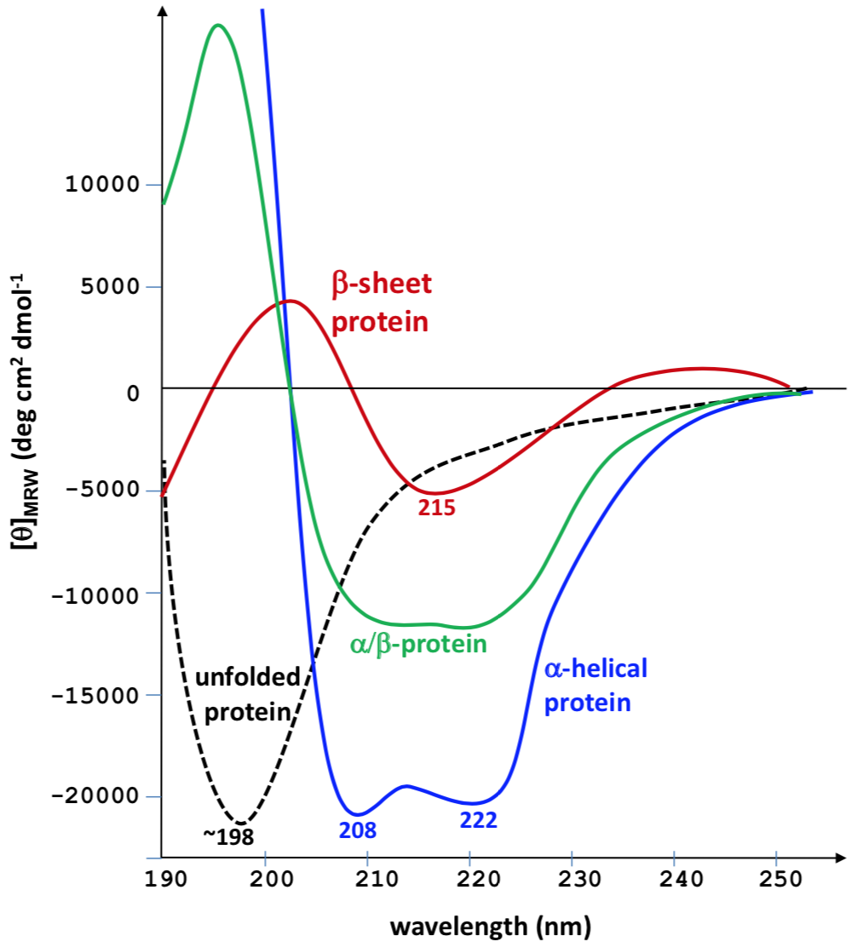

CTD: alpha helical (minimum at 208 and 220 nm in far UV), disappeared at 3.5 M

At 3.5 M GdmCL → beta sheet protein; NTD domain folded at 3.5 GdmCl therefore NTD adopts beta sheet conformation

c) What is the size of the N domain relative to C domain?

again unfolding curve. How is the unfolding curve showing the size difference?

as above with the unfolding curve of C and N domain

**2. Draw an UV absorption spectrum of a protein (Tyrosine, Tryptophan, no chromogenic cofactors).**

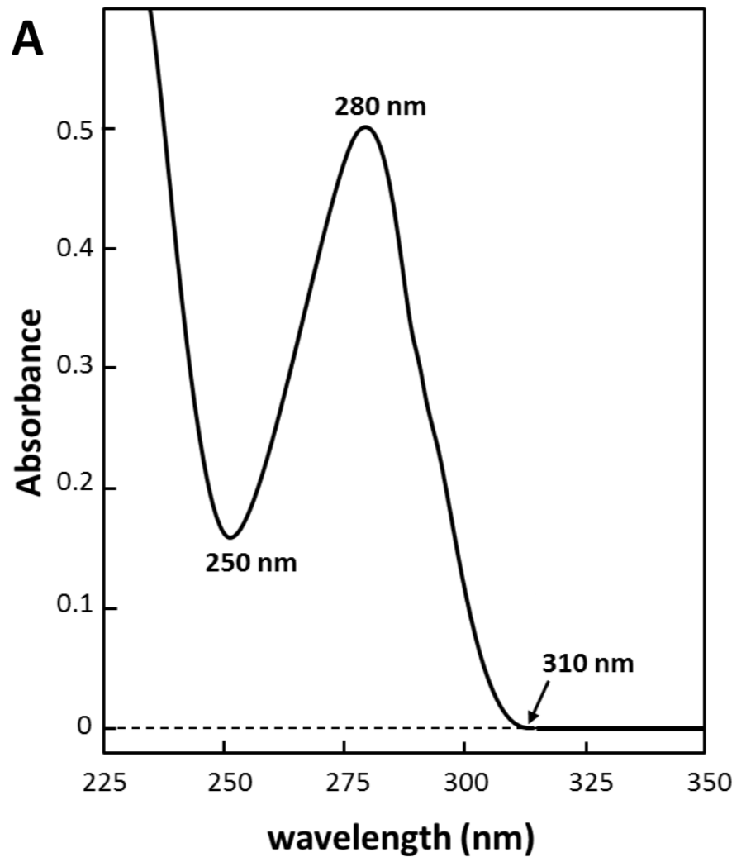

**3. a) Draw a delta G diagram (temperature dependence of protein stability, parameters to calculate 2 state of folding)**

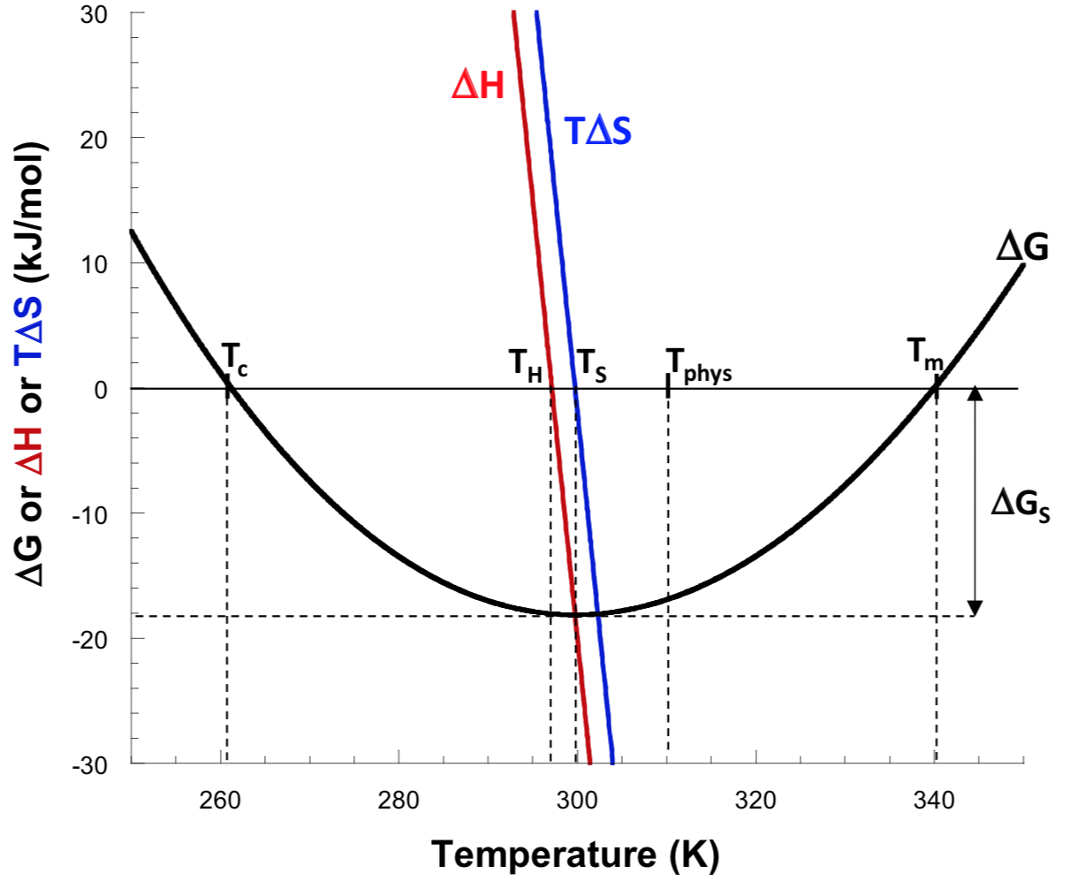

**b) Which parameters need to be known to determine delta G at any temperature?**

ΔHm, Tm, ΔCp.

vant hoff:

$ΔG = ΔHm + Cp (T -Tm) - T(\frac{Hm}{Tm}+ Cp ln(\frac{T}{Tm}))$

**c) Why is it not possible to calculate delta G with thermal unfolding transition?**

It follows from the van‘t Hoff equation (eq. 27, 28) that neither Tm nor ΔHm contains information on the free energy of protein folding ΔG at temperatures other than Tm. It only yields ΔH and Tm but not Delta Cp.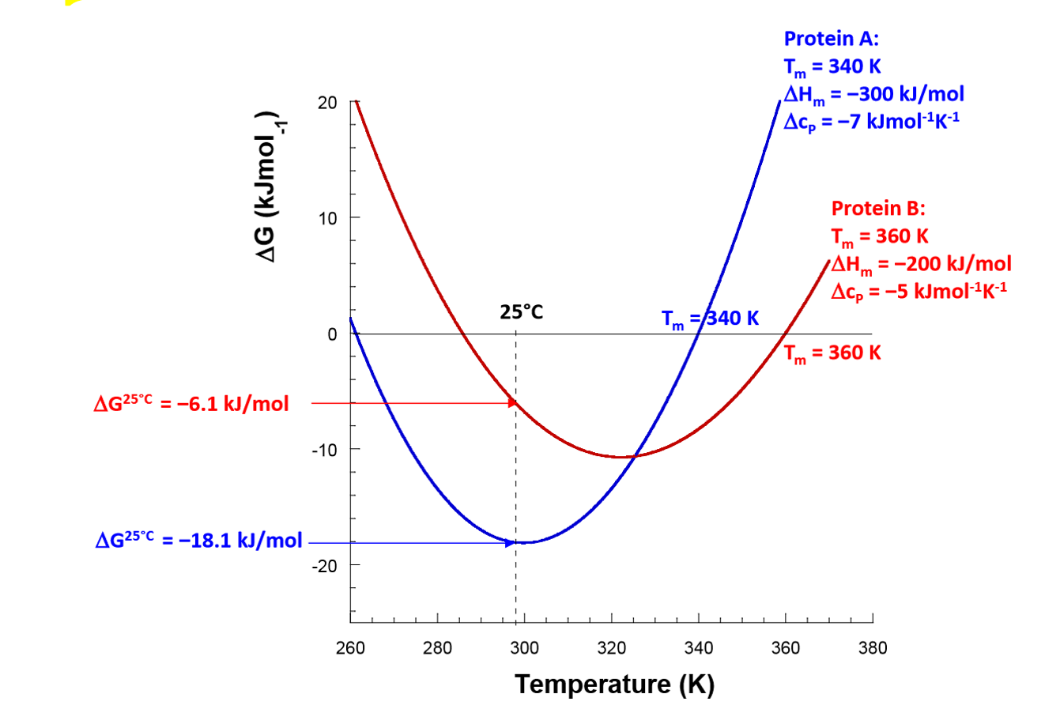

higher ™ doesn’t mean bigger delta G

Cp for correct estimation needed

**4.a) Why can a peptide of the length 10-20 AA not form tertiary structure?**

They are too small for the formation of enough mutually stabilizing intramolecular interactions.

**b) What is the role of enthalpy/entropy for the delta G of folding?**

Enthalpy/entropy compensation. The free energy of folding ΔG is only a small difference of large numbers (according to classical thermodynamics), where ΔH is the enthalpy difference and ΔS is the entropy difference between the two states.

**5.a) Draw NH3+-Arg-Pro-CO2 in cis formation.**

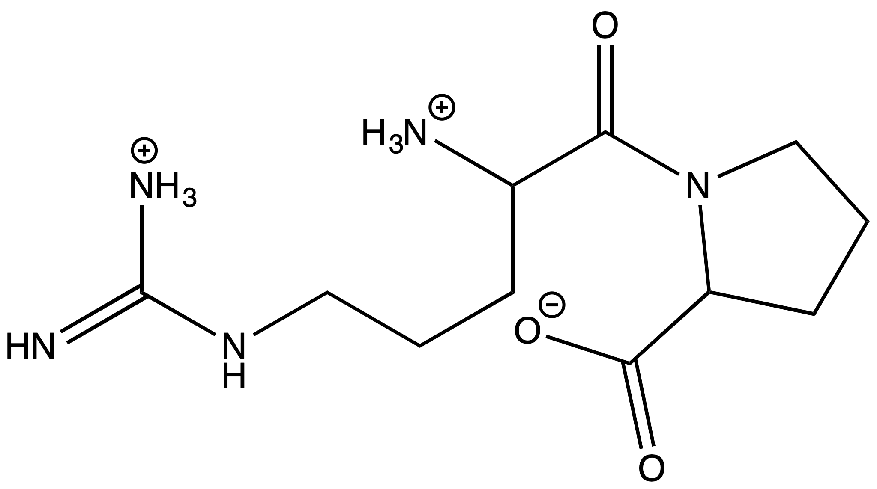

**b) What is the half time of trans -> cis and cis -> trans?**

**trans -> cis:** 100s

**cis -> trans:** 10s

**c) Protein isomerization leads to accumulation of nonnative prolines, which can only be refolded slowly and are prone to unspecific aggregation. Name 2 strategies to suppress unspecific aggregation and to increase the folding yield in an in vitro folding experiment.**

1. Refolding at low protein concentrations to suppress unspecific aggregation.

2. Refolding at low temperatures and low salt concentrations to weaken unspecific hydrophobic interactions.

6.a) Draw a diagram of the native fraction (N) versus the intermediate fraction (I) over time.

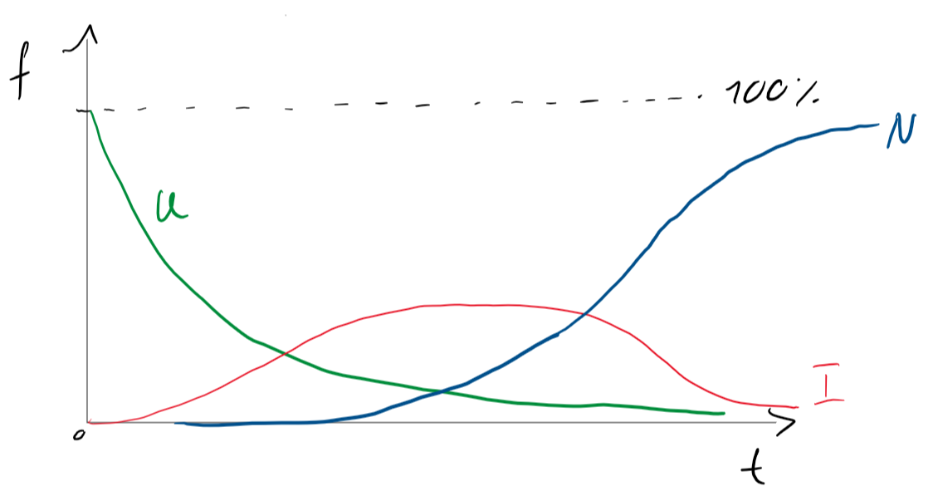

actual fraction

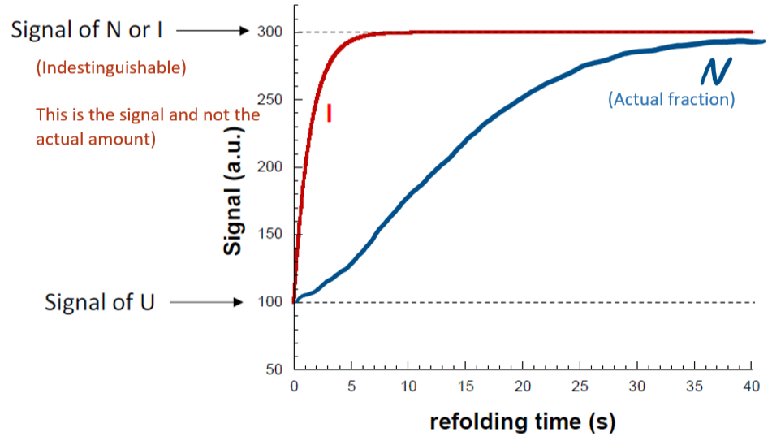

From Ricardo’s notes from the exam. Apparently he wanted the signal you can measure, way to go Glöggli.

**b) How can you quantify the concentration of native molecules at any time during the refolding reaction although your spectroscopic technique doesn’t distinguish between I and N? Draw a diagram.**

Interrupted refolding experiment (N-test):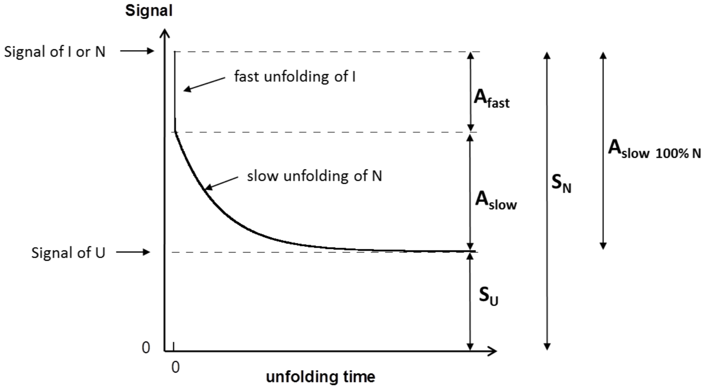

measure at different tim

(who the fuck is tim?)

glockshuber’s boyfriend.

#### 

#### Locher

**7.1 Lipid Layer experiment. Calculation exercise using Nernst equation.**

a) Permanently open Na+

b) Permanently open K+ $E = \frac{RT}{-zF} ln(\frac{{Xout}_{}}{X{in}_{}})$”-z” only when negative charge, only when Cl-

c) Permanently open Cl-

d) ClC E = 1 / (1+m/n) (Ecl + m/n * Eh) m n anzahl atome beim shutteln

**7.2 Draw g-E graph and IV diagram for one of the calculated values from 7.1.**

**Example from the lecture:**

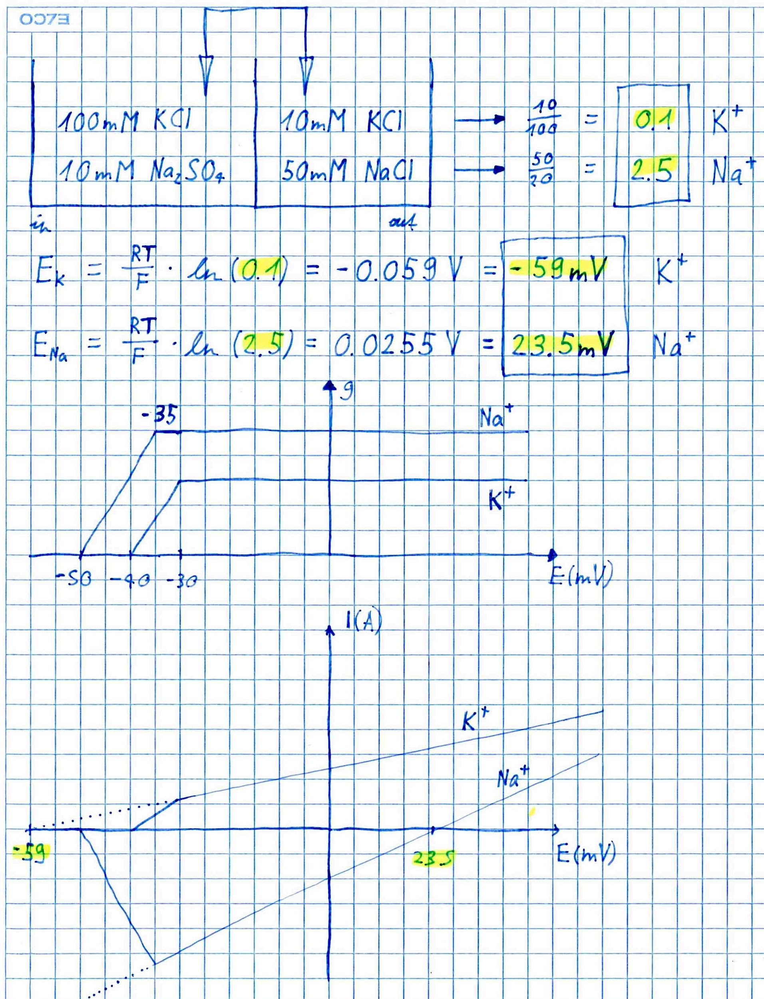

**8. Liposome bilayer (CIC). Draw all components needed.**

*(This answer is not complete btw)*

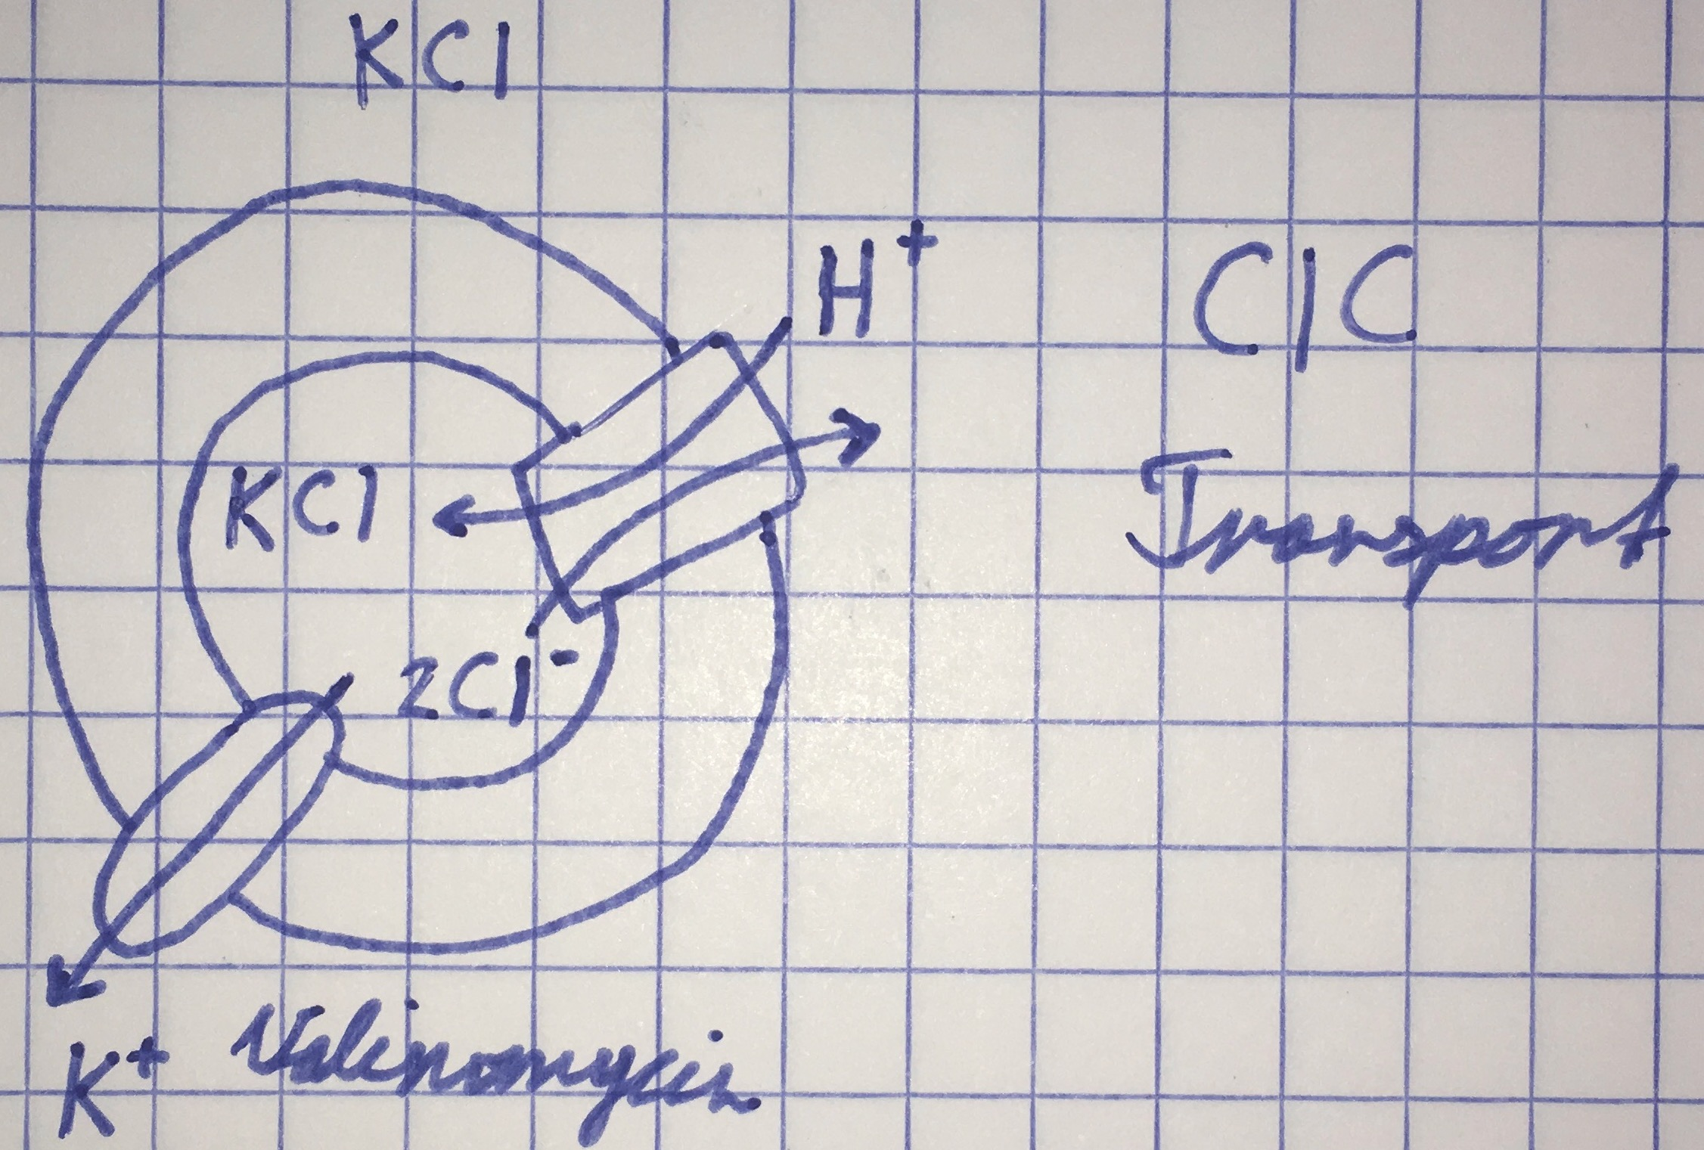

#### Weber-Ban

**9. Name two bacterial Chaperones (shown in picture). Draw the approximal binding site and ATP site.**

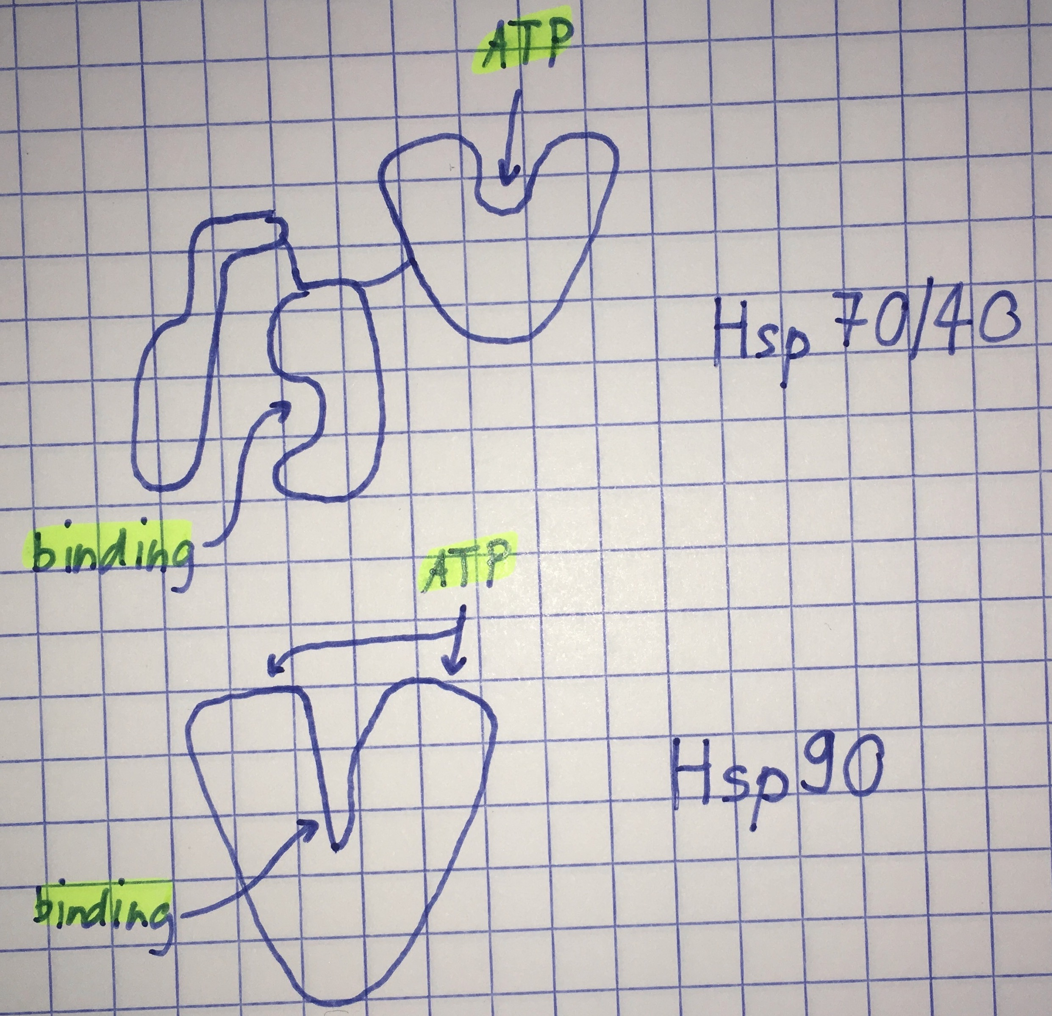

**10. What is the oligomeric shape of AAA complex ClpX and ClpA of Clp protease?**

Ring-shaped oligomer (7 subunits) with entrance pore. (goes for both)

ClpA & X protein unfoldase

ClpP is a serine protease

**How does this serve their function?**

Narrow entrance pores -> Selection via folding state

Ring-stacking principle allows association with ring-shaped partners lining up the pores as a conduit into the proteolytic core ClpP

**11. Draw the linkage formed in ubiquitination. What is this linkage called?**

The linkage is called an “isopeptide bond”:

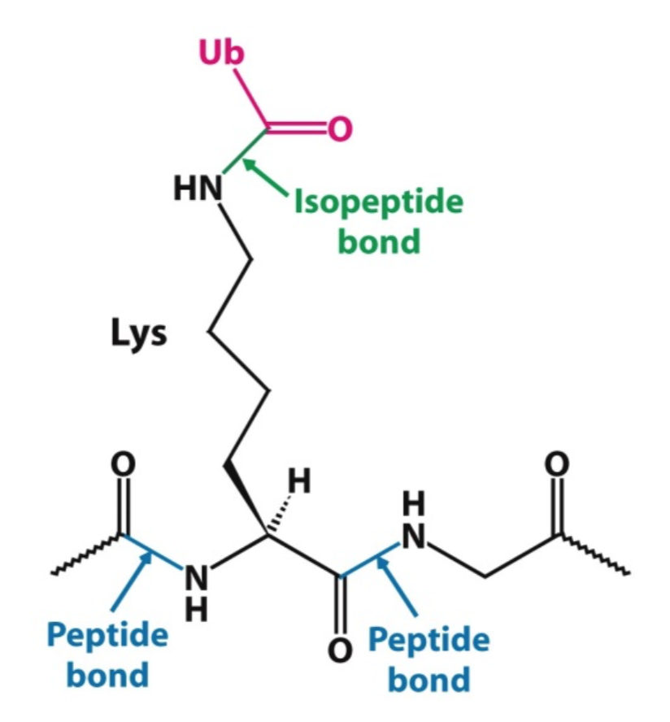

**12. Expression of heterodimeric AB complex. Two bands are visible; 35 kD and 70 kD. The impurity is a chaperone. Which one (35 kD or 70 kD) is it? What is the reason to find it?**

70 kD as HSP 70 was named after it’s Daltons. The reason was it was still folding and had chaperones help to do so.

#### 

#### Ban

**1.a) Draw the wobble base pair between G + U.**

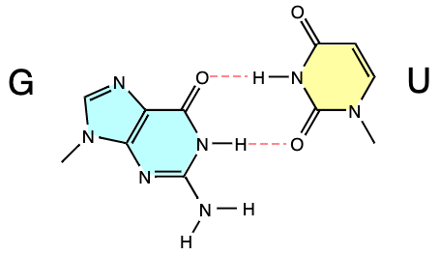

**b) In which position is the wobble base?**

In the third binding site (E-site) for tRNA.

**c) Which part of the ribosome stabilizes this interaction?**

A guanine (G530) flips towards the minor groove of the codon anticodon helix by switching from a syn- to an anti-conformation. The third base also interacts with C1054 and contacts Proline48 of ribosomal protein S12 in a metal-mediated interaction.

also A-minor motifs.

**2.a) How does the rhinovirus hide its conserved Region?**

The conserved region lies within a structural ‘canyon’ of very small dimensions, so that the region is inaccessible to a broad range of antibodies.

**b) What is the conserved region used for?**

Host cell receptor recognition.

**c) What is the proposed mechanism of action of compounds active against rhinovirus?**

The suggested mode of action is that binding of the drug mediates viral stability by reducing the conformational flexibility of the capsid. Thus, inhibiting opening of the viral ssRNA.

**3.a) What is the simplest naturally occurring CRISPR system?**

CRISPR-Cas9.

**b) What is its target?**

Viral dsDNA.

**4.a) Draw the E. Coli SRP (protein + RNA) and indicate the domains. b) Indicate i) Ribosomal interaction ii) GTP hydrolysis iii) Signal sequence binding c) Where on the ribosome does SRP bind?** SRP binds to ribosomal proteins L18 & L23 of 50S.

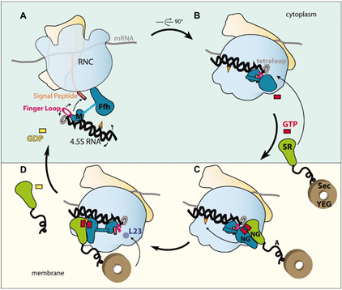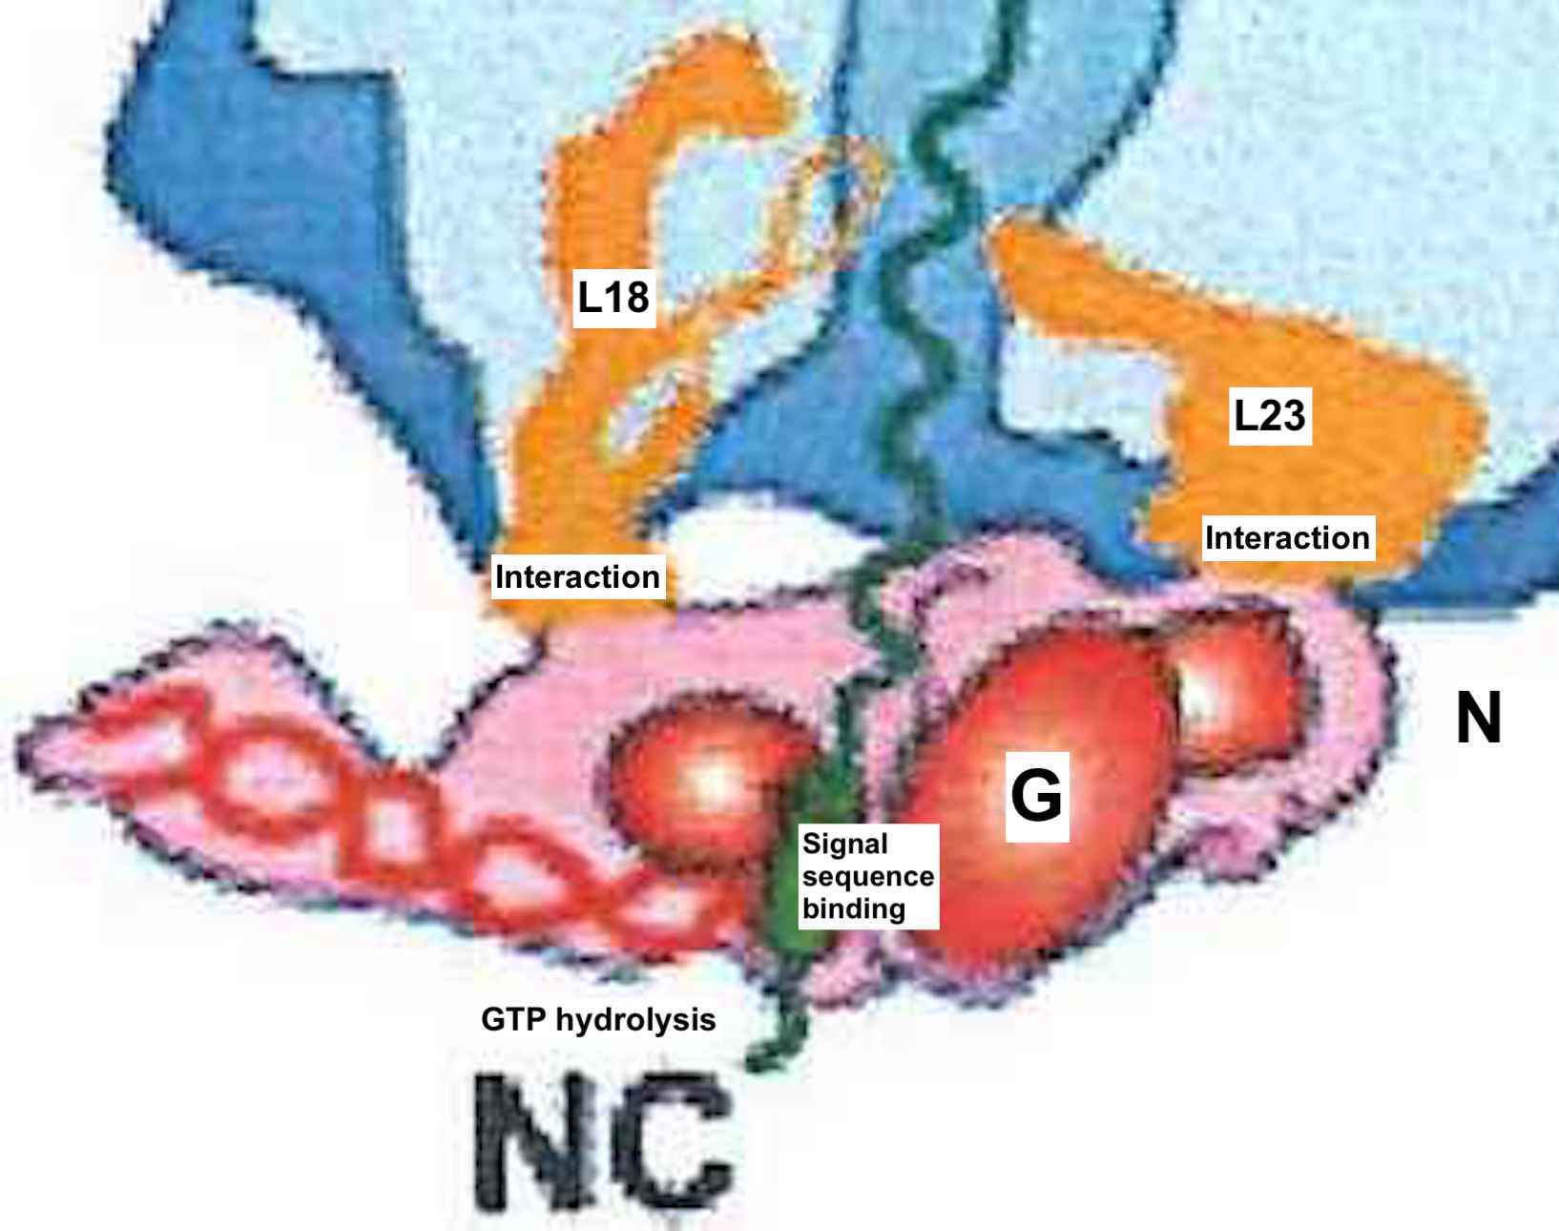

**5.a) What is the length of the ribosomal tunnel?**

100 Å long, narrowest part 10-15 Å wide.

**b) How many amino acids can fit through the tunnel? What is the number for the extended conformation? What is the number for alpha helices?**

30-40 amino acids in extended conformation.

from wikipedia:

3.6 amino acid residues per turn,

->ie. a helix **36 amino acids** long would form 10 turns.

The separation of residues along the helix axis is 5.4/3.6 or **1.5 Angstroms**,

->ie the alpha-helix has a rise per residue of **1.5 Angstroms**

$\frac{100A}{1.5 A aa{{-1}^{}}^{}}$ = **~ 66 aa**  in an alpha helix in the RET

How the fuck should we have known that in the exam?

#### Allain

**6. Loop E motif shown. Describe stacking, pairing and stabilization by comparing it to the A-form helix.**

- S shape

- tetraloop (UUCG) & several non-WC base pairs

- 2x cross-strand stacking

- 1x box triple (GUA) in plane

**7.a) What is a ribozyme?**

RNA molecules that are capable of catalyzing biochemical reactions, similar to protein enzymes.

**b) Draw the secondary structure of a ribozyme you know.**

Hammerhead Ribozyme: Group I intron splicing:

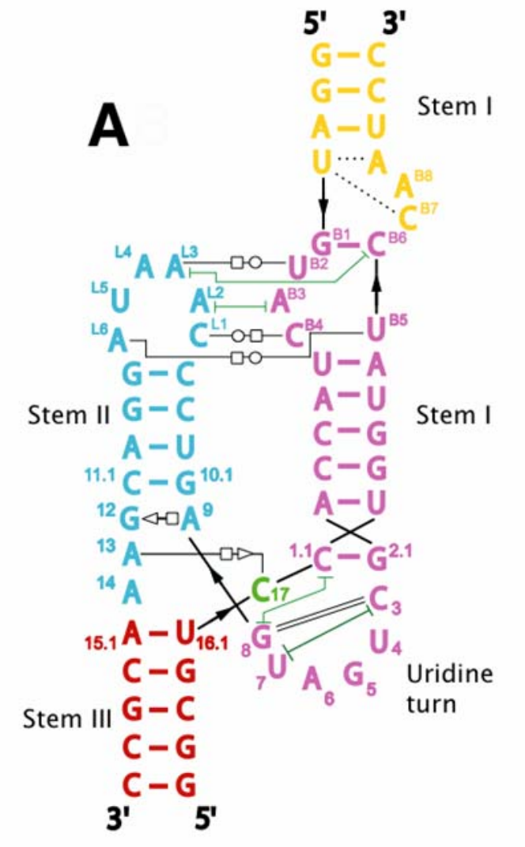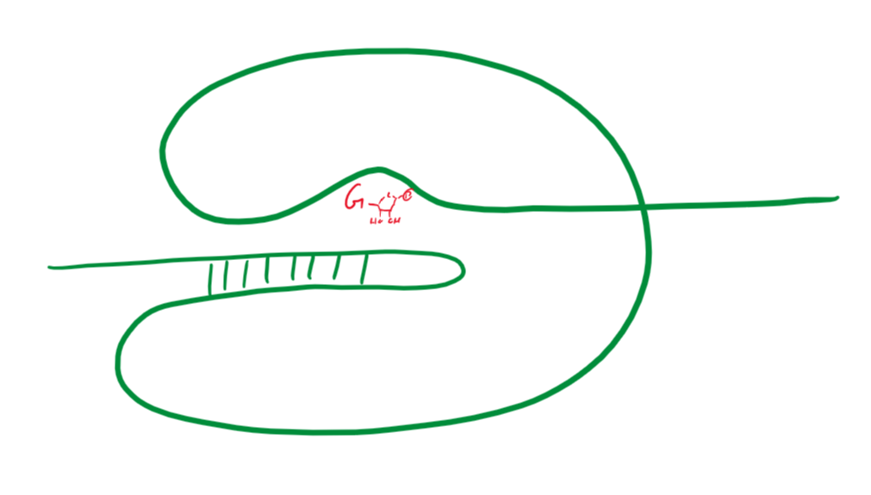

**c) Draw the chemical reaction that this ribozyme catalyzes.**

Phosphodiester isomerization: transesterification: / exonucleolytic splicing

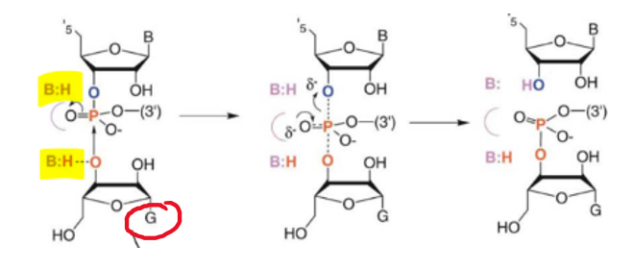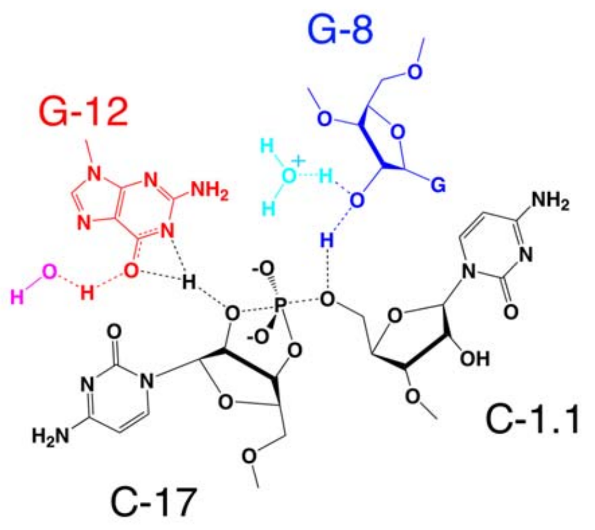

**d) What did the 3D structures reveal about the catalytic mechanism of ribozymes?**

It is now widely accepted that most ribozymes catalyse their reaction using an

acid-base mechanism. and that rna only.

**8. RNA cleavage can be achieved by RNA alone or protein-RNA complexes. Give examples of these different roles played by the RNA or the protein in the different enzymes. Explain how target specificity is achieved.**

**Hint: Introduce all enzyme classes you can remember. Explain for each one what the role and targeting mechanism is for max points.**

|  |  |  |  |
| --- | --- | --- | --- |
| **Description:** | **Enzyme (Part):** | **Role:** | **Specificity:** |
| **RNA only** | Hammerhead Ribozyme | Cleavage & Ligation | Nucleotide pairing |
|  | Hairpin Ribozyme | Cleavage | self cleaving |
|  | Group I | cleavage | nucleotide pairing |
| **RNA & Protein comp.** | Group II | Cleavage & Ligation | Nucleotide pairing |
|  | Ribosome (RNA) | Peptidyl Transfer Reaction, Decoding | Nucleotide pairing |
|  | Ribosome (Protein) | Stability | Charged backbone residues |
|  | Spliceosome (RNA) | Splicing reaction (U2,U5,U6) | Nucleotide pairing |
|  | Spliceosome (Protein) | Structural assembly | - U1 & U2 readings of EJC |
| **Protein (guided by RNA)** | RISC **(AGO2)** | Catalytic domain **(PIWI)** | si/miRNA binding **(PAZ & PIWI)** |
|  | RISC (si/miRNA) | Cleavage | Nucleotide pairing |
|  | Telomerase **(TERT)** | Reverse transcriptase reaction | - |
|  | Telomerase **(TERC)** | template RNA | Nucleotide pairing |
| **Protein only** | Nuclease | Cleavage | Electrostatic interactions |

#### 

#### Pilhofer

**9. Explain the role of the RNA-component in Telomerase.**

Telomerase RNA is used as a template to synthesize new DNA telomeres on the leading strand. the leading strand then works as the template for the lagging strand . primer -> dna polymerase -> ligase

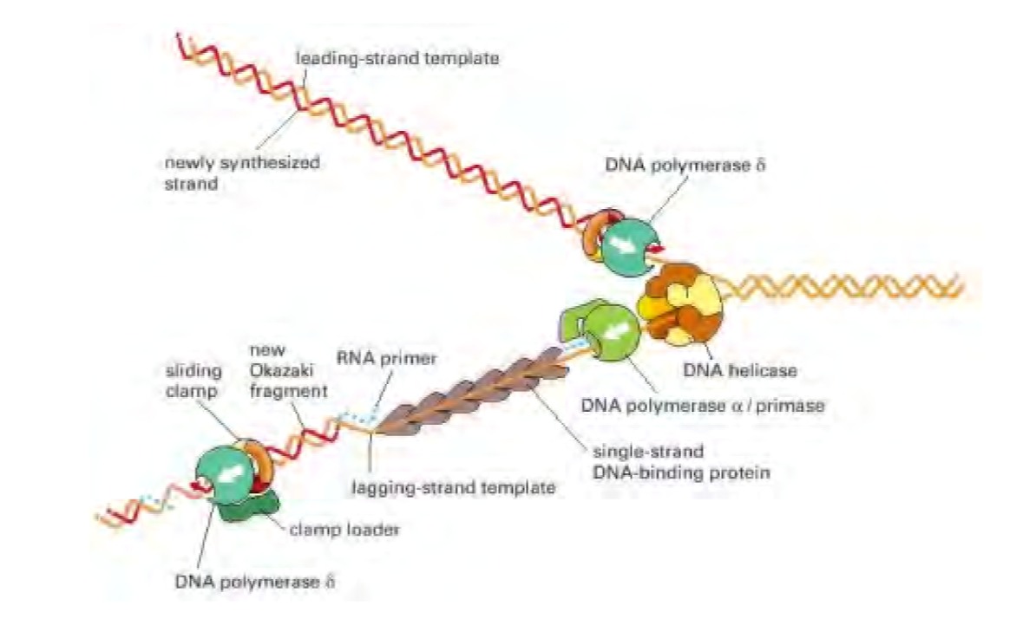

**x 10. Name 4 Tasks conserved across bacterial and eukaryotic replisomes.**

- DNA polymerase

- DNA helicase

- DNA primase

- Sliding clamp

- Clamp loader

- ssDNA binding proteins

**11. Order regarding level of condensation.**

1. dsDNA

2. Histone

3. Nucleosome

4. “Beads-on-a-string” Chromatin

5. 30 nm fiber

**x 12. Name 4 classes of cellular factors that affect eukaryotic chromatin structure.**

- NAPs (H-NS, Fis, IHF, HU, Dps, CpbA) (bacterial)

- ISW1a (histone spacing)

- SMC (density of chromatin)

- SWI/SNF (sliding / removal histone subunits)

- H1 and histone tails (acidic patch)

**13. Describe the main conceptual difference between the “30-nm model” and the “Polymer Melt Model”.**

**30-nm model:** Diluted chromatin

**Polymer melt model:** Concentrated chromatin

Several lines of evidence suggest the absence of regular 30-nm chromatin fibers in eukaryotic cells. It’s been proposed that 10-nm nucleosome fibers exist in a highly disordered, interdigitated state similar to a “polymer melt”.

**Self‐test Questions to «Molecular Chaperones»**

**1. The term “molecular chaperone” was first used to describe “nucleoplasmin”. Explain what type of chaperone nucleoplasmin is and what its function is.**

Nuclear chaperone specialized for egg cells. It assists in the formation of nucleosomes by preventing aggregation of histones with DNA.

When negatively charged DNA and positively charged histones are mixed in solution, irreversible precipitation occurs. Nuclear chaperones prevent this aggregation and help the nucleosome assembly.

**2. Explain the term „molecular chaperone“.**

**Definition:** Molecular chaperones are proteins that assist other macromolecules in folding/unfolding and in assembly/disassembly of higher order structures without being components of these final structures.

**Two criteria:**

1. It must assist the noncovalent assembly/disassembly of another protein-containing structure. The mechanism by which it does this is irrelevant.

2. It must not be a component of these structures when they carry out their biological function in the cell.

**3. Name at least three scenarios inside the cell, where chaperones play a role.**

* Prevention of aggregation of unfolded proteins.

* Assist folding of proteins aggregates.

* Disassembly of proteins.

* Assisting conformational changes in kinases and steroid receptors

**4. Why are many chaperones heat-shock induced proteins?**

During stress, damaged proteins display partial loss of structure that could lead to aggregation or malfunction. Chaperones protect the damaged proteins by binding to their unraveled or misfolded parts thereby preventing them from interaction with each other or with other proteins in non-productive or damaging ways. They also assist their refolding to the fully native conformation or help degrade unrecoverable proteins.

**5. According to Anfinsen, proteins contain all the necessary information for the 3D structure they are to adopt within their primary sequence. So why do we need molecular chaperones? Is this not a contradiction?**

Most denatured proteins refold spontaneously in vitro, but the situation inside the cell provides a greater challenge due to the high total concentration of macromolecules. Folding under such conditions can become „inefficient“, that is, result in a larger fraction of misfolded or aggregated species. Chaperones act to prevent or reverse these competing „side reactions“. Chaperones do not provide steric information required for proteins to fold correctly, but either prevent or reverse aggregation and misfolding processes that would otherwise reduce the yield of functional molecules.

**6. Name at least 4 families of molecular chaperones along with their role inside the cell.**

**\* HSP70, HSP40 Chaperone System:** protein trafficking, protein folding, heat shock

**\* HSP90:** involved in regulating signal transduction pathways

**\* Chaperonins:** assist folding of many proteins

**\* HSP100 Proteins:** Unfoldase component, Disassembly of protein aggregates

**\* Small HSP’s:** mask hydrophobic patches on substrate proteins

**7. What is GroEL/ES?**

Chaperonin that assists the folding of a variety of proteins in the E. *coli* cytosol by cyclic binding and release of substrate polypeptides.

**8. What is the overall architecture of GroEL/ES and how does this relate to its function?**

**GroEL:** Double-ring of two back to back 7-membered rings. It has a shape of a cylinder that contains a large cavity. Three domains (apical, intermediate, equatorial).

**GroES:** Single 7-membered ring. It has a shape of a half-dome. When GroES caps GroEL, a closed chamber is formed.

**9. Describe in schematic terms the subunit structure of GroEL in the GroEL versus GroEL/ES/ATP state. How does this lead to assistance of protein folding for certain substrates?**

**\* 25 downward rotation:** bring intermediate domain down on equatorial domain. -> ATP locked in

**\* 60 upward rotation of apical domain**

**\* 90 twist of apical domain:** causes hydrophobic patches to move away where they are buried in the binding interface with GroES and with other apical domains.

**10. Describe the four stages of the GroEL/ES reaction cycle.**

**1. Polypeptide/ATP binding:** Substrate and ATP bind to open trans ring.

**2. GroES binding:** GroES binding induces conformational changes. Substrate in polar environment.

**3. ATP-hydrolysis timer:** ATP acts as timer, gives substrate some time to fold, then hydrolysis primes GroES to release from cis-ring. Hydrolysis also induces conformational change in trans-ring allowing it to bind substrate and ATP.

**4. Substrate release:** Binding of ATP to the trans ring induces dissociation of the cis ligands.

**11. Name two differences between the GroEL/ES and the Hsp70/40 chaperone systems.**

**1.** HSP70/40 has entirely different architecture; it is no complex of subunits but a single protein with two main domains.

**2.** HSP70 relies on co-chaperons for ATP/ADP exchange and ATPase activity stimulation.

**12. What is the function of the Hsp70/40 chaperone system when it acts co-translationally?**

Assisted folding of newly translated proteins.

**13. Name two principle differences between the Hsp70/40 and the GroEL/ES chaperone systems.**

Maybe that GroEL/ES compartmentalizes the substrate while Hsp70/40 doesn’t?

**14. What is the overall domain structure of Hsp70, what are the functions of the different domains? Could you identify them in a structure depiction?**

**ATPase domain:**

Overall structure: Two large lobes separated by a deep cleft.

ATP binding pocket: Two phosphate binding loops and a hydrophobic adenosine binding pocket.

**Substrate binding domain:**

Overall structure: β-sandwich of two 4-stranded sheets followed by two helices.

Substrate binding pocket: Top β-sheet emanates 4 loops that make contacts with the inner helix. The inner two loops form a channel with a crosssection of ~5 X 7 Å, the substrate binding pocket. The helix functions as a lid allowing entry/release of substrate.

**15. What is post-translational quality control?**

**Structural maturation of proteins:** Mediated protein folding, protection from misfolding and aggregation, disaggregation, degradation.

**Self‐test Questions to «Cellular Protein Degradation Machines»**

**1. Explain the term «Protein Turnover».**

Protein synthesis, folding, and degradation.

**2. What are the two main intracellular protein degradation routes in eukaryotic cells?**

**Ubiquitin-protease system:** Compartmentalization inside a proteinaceous particle.

**Autophagy-lysosome system:** Compartmentalization inside an organelle, separated from cytosol by membrane.

**What do they have in common?**

Compartmentalization.

**3. Why are protein degradation machines energy-dependent?**

Peptide bonds are kinetically stable. Breaking those bonds requires energy (ATP hydrolysis).

**4. Why are protein degradation machines sequestering the proteolytic sites in a compartment?**

**Compartmentalization provides the following features:**

- Separation of substrate from bulk cytosol

- Selection via folding-state -> narrow entrance pores

- Processivity by encapsulation of the protein -> substrate is cleaved down to peptide size

- ring-stacking principle allows association with ring-shaped partners lining up the pores as a conduit into the proteolytic core

**5. What is referred to as kinetic stability? What is the reason for the kinetic stability of the peptide bond?**

The resonance structure of the peptide bond shows that it has partial double-bond character. The electron lone pair of the nitrogen delocalizes such that a higher electron density is found between the C and N-Atom than in a regular single bond. This on the other hand makes the carbonyl carbon less electrophilic and thus less susceptible to a nucleophilic attack.

**6. Explain what is referred to as «covalent catalysis» of proteases? Draw the general reaction mechanism for covalent catalysis.**

Attack by enzyme residue as nucleophile:

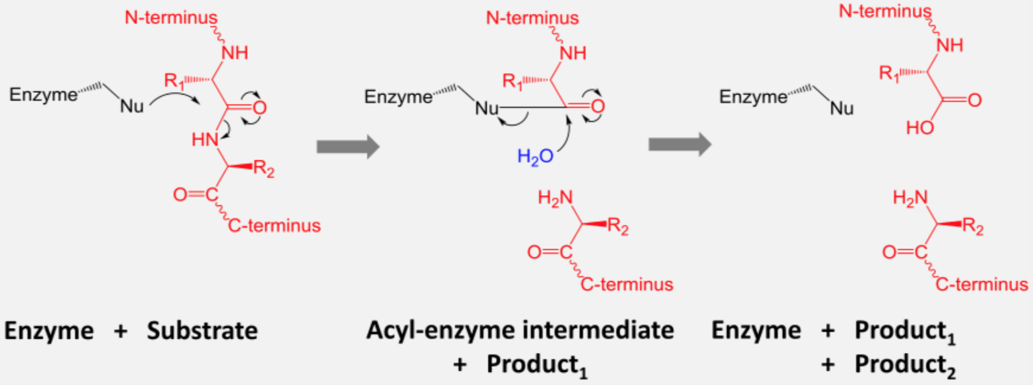

**7. The ATPase-components of energy-dependent proteases belong to the AAA family. Explain (briefly) the subunit structure and properties of the AAA module as well as their assembly state.**

AAA module: 230-250 aa sequence containing P-loop ATPase fold (Walker A, B) and α-helical domain.

**8. What is the «N-end rule»?**

Rate of degradation determined by N-terminal residues.

**Primary destabilizing residues:** Phenylalanine, Leucine, Tryptophan, Tyrosine

**Secondary destabilizing residues:** Arginine, Lysine

**9. What is ubiquitin?**

Recruitment tag for 26S Protease.

**10. Why is ubiquitin such a versatile protein modification?**

Ubiquitination happens in a variety of forms. Different Ub-chain types show different topologies.

**11. Which enzymes are responsible for the modification of target protein with ubiquitin?**

Ubiquitin ligases (E1, E2, E3).

**12. What is necessary for a target protein to be degraded by the proteasome in a Ub‐dependent manner, ie describe the substrate determinants for recognition and processing at the proteasome.**

* N-end rule

* PEST sequences

* Cycline destruction boxes

**13. Draw a schematic representation of the 26S proteasome, name and label the main components.**

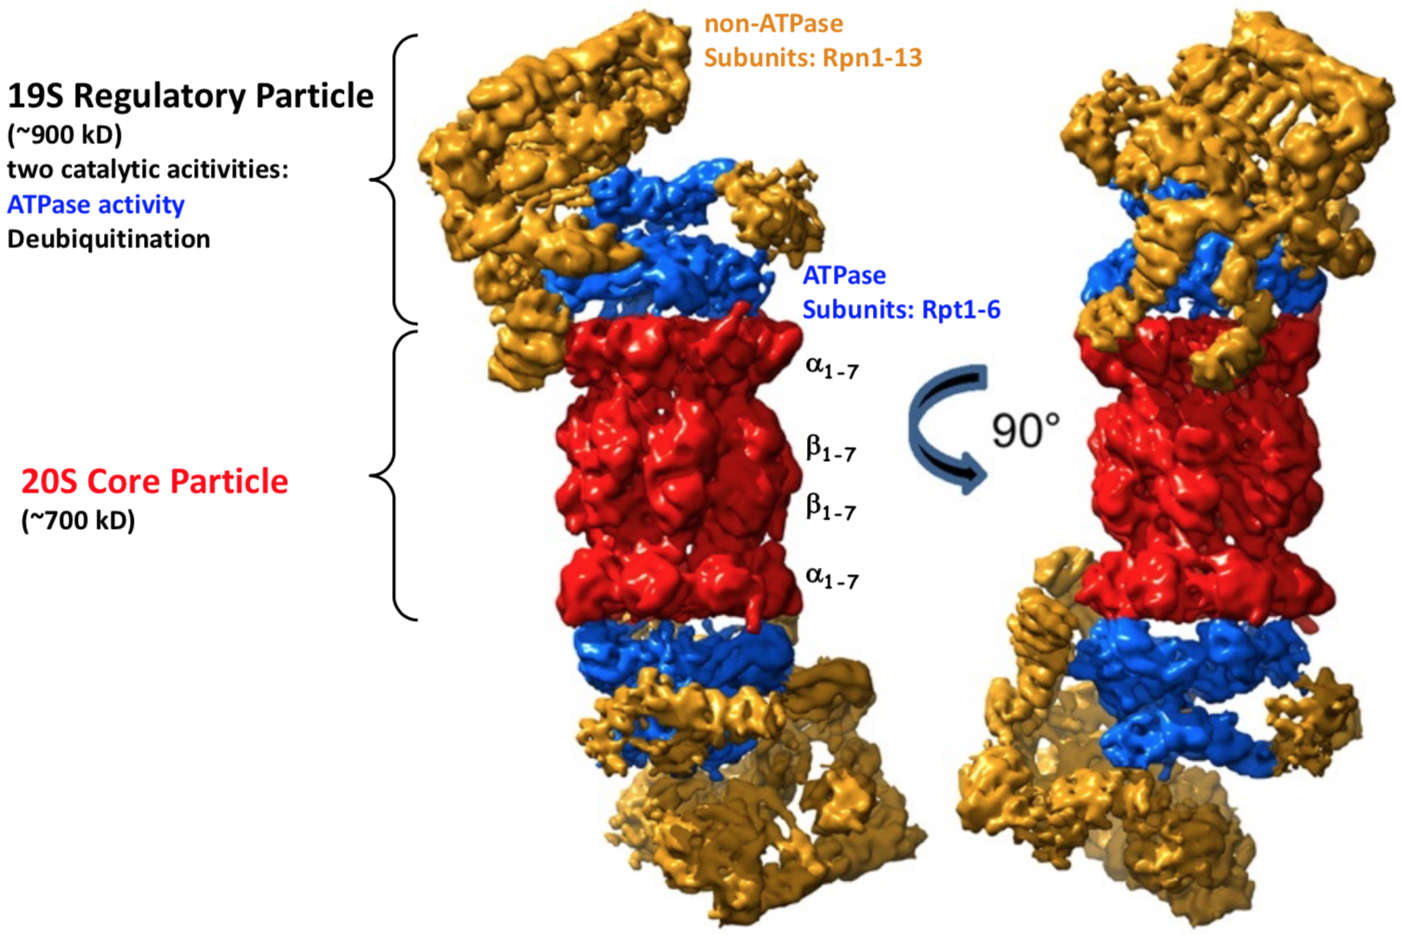

**Ban Questions: Viruses**

**1. Explain the T=1, T=3 and P=3 virus capsid architecture.**

**T=1:** All subunits identical. 60 subunits. Threefold axis exact.

**T=3:** Three subunits. Threefold axis A, B, C. Five A subunits around fivefold axis. B, C alternate around threefold axis, which are also pseudo-sixfold axes.

**P=3:** Like T3, but quasi-symmetry is less exact (subunits need not be identical proteins, but simply need to share the same fold to fulfill quasi-equivalence).

**2. What are the technical difficulties in determining structures of viruses?**

Enveloped viruses have been more difficult to study at moderate high resolution, because their flexible capsids prevent crystallization or image analysis.

The structure determination of virus particles is limited by the availability of diffraction quality crystals. Crystals of whole virus particles have large unit cell dimensions.

**Why is it also often difficult to determine structures of isolated capsid proteins?**

The amino terminal regions of viral capsid proteins are highly positively charged and very flexible. Consequently, they are usually not visualized in crystallographic experiments since they lack defined conformation.

What are the differences in structure determination of icosahedral viruses versus large asymmetric assemblies such as the ribosome?

**3. Which percentage of STMV genome is visible within the capsid? Which types of RNA sequences are visible?**

T=1, 1059 bases of ssRNA; remarkable propensity to form double strands (in general: extensive secondary structures) -> inside the highly symmetric capsid there is an asymmetric genome.

By EM, part of the genome is visible, because of local double helical symmetry. Electron density of the capsid protein dimer could be fitted with 7 bp of dsRNA.

- Dyad axes (two areas of a [DNA](https://en.wikipedia.org/wiki/DNA) strand whose base pair sequences are [inverted repeats](https://en.wikipedia.org/wiki/Inverted_repeat) of each other) of the central bp are precisely coincident with the icosahedral 2-fold symmetry.

- Helical axes lie in the plane defined by the 5-fold axes (parallel to the edges of the icosahedron).

So, to see something inside the virus, the content has to follow for an extent the symmetry of the capsid.

**4. What is unique about the architecture of the SV40 virus?**

72 capsomeres in skewed T=7 geometry

(T=7 should have 420 subunits (60 hexamers and 12 pentamers))

Pentamers at all predicted capsomere positions: (60+12)x5=350 subunits of VP1* -> asymmetric unit contains 6 and not 7 subunits!

- 12 pentamers lie at the 5-fold axes (strict pentamers) each surrounded by 5 pentamers (local)

- 60 pentamers do not lie on symmetry axes, and are surrounded by 6 other pentamers (1 strict and 5 local)

* VP1 consists of 3 modules: N-terminal arm; an antiparallel β-sheet (jelly roll); and a long C-terminal extension.

The core of strict and local pentamers varies in the region of pentamer contacts.

Pentamers is formed by the tight packing of the jelly roll β-barrels around the 5-fold axis.

In the fully assembled virus, most pentamers contact each other through the C-terminal arm. 3 kinds of inter-pentamer clusters:

- 1 3-fold cluster: 1 strict and 2 local pentamers; 3 α-helices form a bundle at the center. Subunit faces approach each other directly.

- 2 2-fold clusters: 2 local pentameric vertex-vertex contacts

**Ban Questions: Translation**

**1. What is the function of the large ribosomal subunit and what of the small ribosomal subunit in protein synthesis?**

**Large subunit:** Peptidyl Transfer Reaction, Translocation.

**Small subunit:** Decoding.

2. What are the major stabilizing interactions responsible for the formation of large ribonucleoprotein assemblies such as the ribosome?

#### The ribosomal proteins themselves.

**3. Many antibiotic compounds target the ribosome. How is protein synthesis inhibited by spectinomycin?**

Spectinomycin = aminoglycoside antibiotic. Binds to the head region of 30S subunit (minor groove at one end of helix 34). Inhibits EF-G catalyzed translocation of peptidyl tRNA from A site to P site.

**How do macrolides impair protein synthesis?**

Bind to the exit tunnel of large subunit and block diffusion of nascent polypeptide. Binding site between peptidyl transferase center and narrowest part of tunnel fenced by L4 and L22.

**Which additional binding sites on the ribosome could be exploited for the design of new antibiotic compounds?**

Decoding center, Shine-Dalgarno site etc.

**4. What would be the structure of ribosomal proteins when isolated from the ribosome?**

Ribosomal proteins are mostly positively charged. The regions that would normally attach to RNA would be exposed and attach to other molecules and likely result in a considerably different overall structure.

**5. Which substrate RNAs interact with the ribosome through A-minor interactions?**

The interactions between the 3′ terminal adenine of tRNAs bound in either the A site or the P site with 23S rRNA are examples of functionally significant A-minor interactions.

**6. What would you expect would happen if you would treat the large ribosomal subunit with peptidases and test for catalytic activity using puromycin reaction?**

Peptidases will break down ribosomal proteins and severely impact the ribosome’s stability. Puromycin reaction results in a premature termination during translation. So basically no catalytic activity at all.

**How about after treating with RNAses?**

Even worse, RNAses will break down RNA and therefore destroy any chance of catalytic activity for the ribosome.

**What would happen if you would artificially synthesize 23S rRNA and test for activity?**

23s rRNA is only responsible for binding and recognition of tRNA and nothing more, so no translational activity.

**What would happen if you would delete genes encoding different ribosomal proteins one by one, would the mutant bacteria be viable?**

Some proteins are more important than others, but a fair number of proteins would most likely be able to be deleted without fully shutting down a ribosome, but the ribosome would most likely be less stable and therefore less efficient.

**Which proteins would be most important and why?**

* L4 & L22 (exit tunnel)

* L11 (GTPase activator)

* L23 (cotranslational protein folding, trigger factor, SRP, translocon targeting)

* L29 (trigger factor, SRP)

**7. What is the difference between the folding of a protein denatured with urea in vitro and in vivo situation in the cytoplasm of a bacterial cell?**

#### In vitro you don’t have any chaperones nor ubiquitin.

**8. What are the functions of the signal recognition particle and trigger factor?**

**Trigger factor:** Molecular chaperone assisting in co-translational folding.

**Signal recognition particle:** Assists cotranslational transport into or across a membrane.

**9. What is the role of L23?**

Attachment point for trigger factor and SRP. Translocon targeting.

**10. How is a membrane protein targeted to and integrated into the membrane?**

Nascent chains destined for membranes carry a signal sequence (more than 15 aa) at the N-terminus. SRP binds to L23 and L29 and interacts with signal sequence. Translation is arrested and the SRP complex is targeted to the membrane by a SRP receptor. The ribosome nascent chain complex (RNC) is transferred to the translocon and SRP and its receptor dissociate from the RNC after GTP hydrolysis. Translation resumes.

**11. Why is it important that the translocation process occurs co-translationally?**

Because it’s easier to pull an unfolded protein through the translocon right after translation so it can fold later instead of having to unfold a native protein just for the translocation process.

**12. Why is it important that the eukaryotic SRP stalls protein synthesis?**

It facilitates the coupling of the translation and translocation processes.

**13. Describe how the cytoplasmic ion environment is sealed against the periplasm during cotranslational protein translocation.**

There is a 15 A gap between the ribosome and the translocon, suggesting the translocon itself is an ion-tight seal to the lumen.

**14. What could provide the energy for protein translocation into the periplasm?**

GTP hydrolysis of EF-G on Sec61/62/63.